Specific Requirements

  - External Interface Requirements
This section provides a detailed description of all inputs into and outputs from the system. It also gives a description of the hardware, software and communication interfaces and provides basic prototypes of the user interface.
    - User Interfaces
A first-time user of the mobile application should see the log-in page when he/she opens the application, see Figure 2. If the user has not registered, he/she should be able to do that on the log-in page.
If the user is not a first-time user, he/she should be able to see the search page directly when the application is opened, see Figure 3. Here the user chooses the type of search he/she wants to conduct.
Every user should have a profile page where they can edit their e-mail address, phone number and password, see Figure 4. Also, the user can set the mobile application to his/her preferred language. The “P” icon shows where the user can click to navigate to his/her profile page.

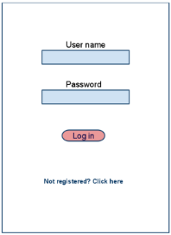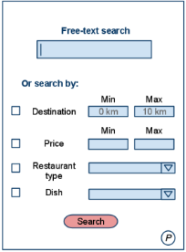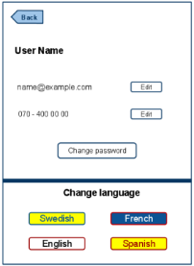
Figure 2 Login Page Figure 3 Search Page Figure 4 Profile Page

In Figure 5, the list view for the results is shown. When a user searches by price, this view should be the default one. The sorting header allows the user to sort the results according to price, restaurant name, distance, restaurant type and specific dish. Each result item includes information about the restaurants, a link to the restaurant’s web-page and an information link, which provides a more detailed description of the restaurant. There is also a filtering option, where the user can choose to filter the results by increasing or decreasing the price or distance range, see Figure 7.
In the map view each restaurant is represented by a pin, see Figure 6. Next to every pin there is an information link which provides a more detailed description of the restaurant, as mentioned for the list view. The same filtering option, as for the list view, is included in the map view.
The restaurant owners and administrators interact with the system through a web-portal, see Figure 8. A restaurant owner should be able to register on the web-portal in order to log in and manage the restaurant information. An administrator should also be able to log in to the web-portal where he/she can administer the system by for instance editing restaurant or user information.

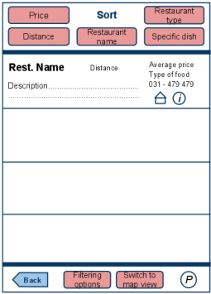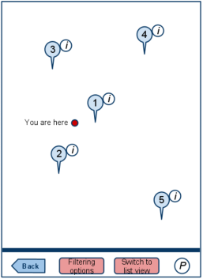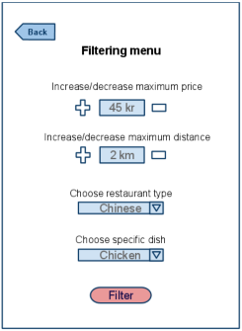
Figure 5 List View Figure 6 Map View Figure 7 Filter Menu

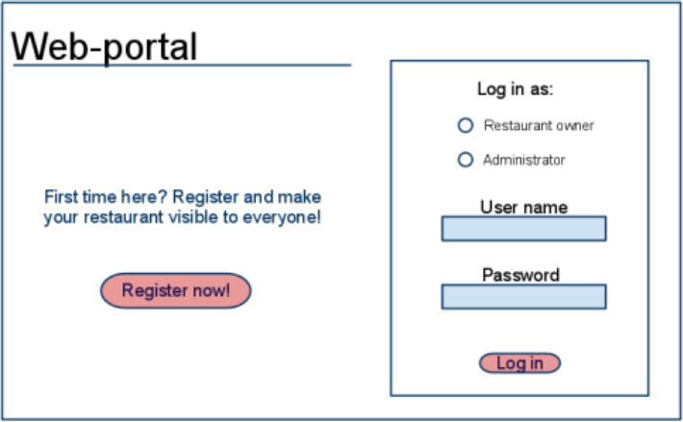
Figure 8 Web Portal

    - Hardware Interfaces
Since neither the mobile application nor the web portal have any designated hardware, it does not have any direct hardware interfaces. The physical GPS is managed by the GPS application in the mobile phone and the hardware connection to the database server is managed by the underlying operating system on the mobile phone and the web server.

    - Software Interfaces
The mobile application communicates with the GPS application in order to get geographical information about where the user is located and the visual representation of it, and with the database in order to get the information about the restaurants, see Figure 1. The communication between the database and the web
portal consists of operation concerning both reading and modifying the data, while the communication between the database and the mobile application consists of only reading operations.

    - Communication Interfaces
The communication between the different parts of the system is important since they depend on each other. However, in what way the communication is achieved is not important for the system and is therefore handled by the underlying operating systems for both the mobile application and the web portal.

  - Functional Requirements
This section includes the requirements that specify all the fundamental actions of the software system.
Table 2. represent actors and their goals in our system

Actor(s) | Goal(s)
Mobile User | - Create account  - Login  - Retrieve password  - Search a restaurant  - View results in a map  - View results in a list view  - Navigate to a restaurant  - Switch to result view  - Select information link  - Search by price  - Search by destination  - Accept input in price and destination  - Search by restaurant type  - Search by specific dish  - Free-text search  - No match found  - Sort result  - Filter results  - View profile page
Restaurant Owner | - Create an account  - login  - select preferred language in web portal  - manage restaurant dishes  - manage restaurant information
Administrator | - create an account  - login  - verify restaurant owner  - manage restaurant types  - manage users  - manage restaurant owners  - select preferred language in web portal

Table 3. represent Use case description styles in our system

Use Case Name and ID | Form
UserUC1, AdminUC1and Rest. OwnerUC1: Create an account | Brief
UserUC2, AdminUC2 and Rest. OwnerUC1: Login | Fully-Dressed
UserUC3: Search a Restaurant | Fully-Dressed
UserUC4: View results | Fully-Dressed
UserUC5: Switch Views | Fully-Dressed
UserUC6: Navigate to Restaurant | Brief
UserUC7: Sort Results | Brief
UserUC8: Filter Results | Brief
UserUC9: View Profile Page | Brief
AdminUC3: Verify Restaurant Owner | Fully-Dressed
AdminUC4: Manage Restaurant Types | Fully-Dressed
AdminUC5: Manage Users | Fully-Dressed
AdminUC6: Manage Restaurant Owners | Fully-Dressed
Rest. OwnerUC3: Select Language | Fully-Dressed
Rest. OwnerUC4: Manage Restaurant Infor. | Fully-Dressed
Rest. OwnerUC5: Manage Restaurant Dishes | Fully-Dressed

UserUC1, AdminUC1and Rest. OwnerUC1: Create an account
DESC: Given that a user has downloaded the mobile application, then the user should be able to register through the mobile application. The user must provide user-name, password and e-mail address. The user can choose to provide a regularly used phone number.

Use Case Name | Login
Trigger | The user should be able to log in the mobile application
Precondition | The user must be register in the mobile application
Basic Path | - the login form is opened  - the user enter his user name and password  - the user clicks login button
Alternative Paths | If there is a different steps for this function in special cases
Postcondition | What are the outputs for this function

Use Case Name | Search a Restaurant
Trigger | In order to for a user to search for a restaurant
Precondition | The user is logged in to the mobile application
Basic Path | - The search page is opened  - The user selects the search option  - The user write down his/her criteria  - the user clicks the search button
Alternative Paths | *a- at any time system fails  1- user restart app, login  1a- system detects anomalies state  - system signals error to the user  - the user re-login  2a- Multiple criteria  - user enters restaurant destination, price, restaurant type and dish  2b- Free-Text  - the user enters a text for the search
Postcondition | The restaurant information or a restaurant map

Use Case Name | Select Language
Trigger | In order to understand the web portal
Precondition | The restaurant owner is login
Basic Path | - select language page opened  - given the Rest. Owner wants to select a preferred language
Alternative Paths | 2a- select English as preferred language  - the web portal will show all text in English  2b- select French as preferred language  - the web portal will show all text in French  2c- select Spanish as preferred language  - the web portal will show all text in Spanish
Postcondition | The web portal language changed

Use Case Name | Name of the use case for the function
Trigger | The main use of this function
Precondition | what are the conditions required to act this function
Basic Path | Provide a bulleted list describe the steps for this function
Alternative Paths | If there is a different steps for this function in special cases
Postcondition | What are the outputs for this function
Exception Paths | Is there are any exceptions may occur
Other | Any detail about the function

UserUC6: Navigate to Restaurant

Use Case Name | Name of the use case for the function
Trigger | The main use of this function
Precondition | what are the conditions required to act this function
Basic Path | Provide a bulleted list describe the steps for this function
Alternative Paths | If there is a different steps for this function in special cases
Postcondition | What are the outputs for this function
Exception Paths | Is there are any exceptions may occur
Other | Any detail about the function

Use Case Name | Name of the use case for the function
Trigger | The main use of this function
Precondition | what are the conditions required to act this function
Basic Path | Provide a bulleted list describe the steps for this function
Alternative Paths | If there is a different steps for this function in special cases
Postcondition | What are the outputs for this function
Exception Paths | Is there are any exceptions may occur
Other | Any detail about the function

Use Case Name | Name of the use case for the function
Trigger | The main use of this function
Precondition | what are the conditions required to act this function
Basic Path | Provide a bulleted list describe the steps for this function
Alternative Paths | If there is a different steps for this function in special cases
Postcondition | What are the outputs for this function
Exception Paths | Is there are any exceptions may occur
Other | Any detail about the function

Use Case Name | Manage Restaurant Dishes
Trigger | In order to have a list of dishes
Precondition
Basic Path | - the control panel page of dishes is opened  - the user selects the action he wants to perform  - the user saves changes
Alternative Paths | 2a- Add a new dish  - new dish page is opened  - the user write the dish information  2b- Edit an existing dish  - the user selects dish he wants to edit  - the editing page is opened  - the user writes/changes dish information  2c- Delete a dish  - the user selects dish he wants to delete  - the user confirming the deletion
Postcondition | What are the outputs for this function
Exception Paths | Is there are any exceptions may occur
Other | Any detail about the function

Use Case Name | Name of the use case for the function
Trigger | The main use of this function
Precondition | what are the conditions required to act this function
Basic Path | Provide a bulleted list describe the steps for this function
Alternative Paths | If there is a different steps for this function in special cases
Postcondition | What are the outputs for this function
Exception Paths | Is there are any exceptions may occur
Other | Any detail about the function

  - Non-Functional Requirements
The requirements in this section specify the required reliability, availability, security and maintainability of the software system.
    - Reliability
GIST | The reliability of the system.
SCALE | The reliability that the system gives the right result on a search
METER | Measurements obtained from 1000 searches during testing
MUST | More than 98% of the searches
PLAN | More than 99% of the searches
WISH | 100% of the searches

    - Availability
GIST | The availability of the system when it is used
SCALE | The average system availability (not considering network failing)
METER | Measurements obtained from 1000 hours of usage during testing.
MUST | More than 98% of the time
PLAN | More than 99% of the time
WISH | 100% of the time

    - Security
GIST | Security of the communication between the system and server.
SCALE | The messages should be encrypted for log-in communications, so others cannot get user-name and password from those messages
METER | Attempts to get user-name and password through obtained messages on 1000 log-in session during testing
MUST | 100% of the Communication Messages in the communication of a log-in session should be encrypted

GIST | Security of accounts
SCALE | If a restaurant owner tries to log in to the web portal with a non-existing account then the restaurant owner should not be logged in. The restaurant owner should be notified about log-in failure
METER | 1000 attempts to log-in with a non-existing user account during testing
MUST | 100% of the time

    - Maintainability
GIST | Application extendibility
DESC | The application should be easy to extend. The code should be written in a way that it favors implementation of new functions
RAT | In order for future functions to be implemented easily to the application

GIST | Application testability
DESC | Test environments should be built for the application to allow testing of the applications different functions
RAT | In order to test the application

    - Portability
GIST | The reliability of the system.
SCALE | The reliability that the system gives the right result on a search
METER | Measurements obtained from 1000 searches during testing
MUST | More than 98% of the searches
PLAN | More than 99% of the searches
WISH | 100% of the searches

